**FSD PO REPORT**

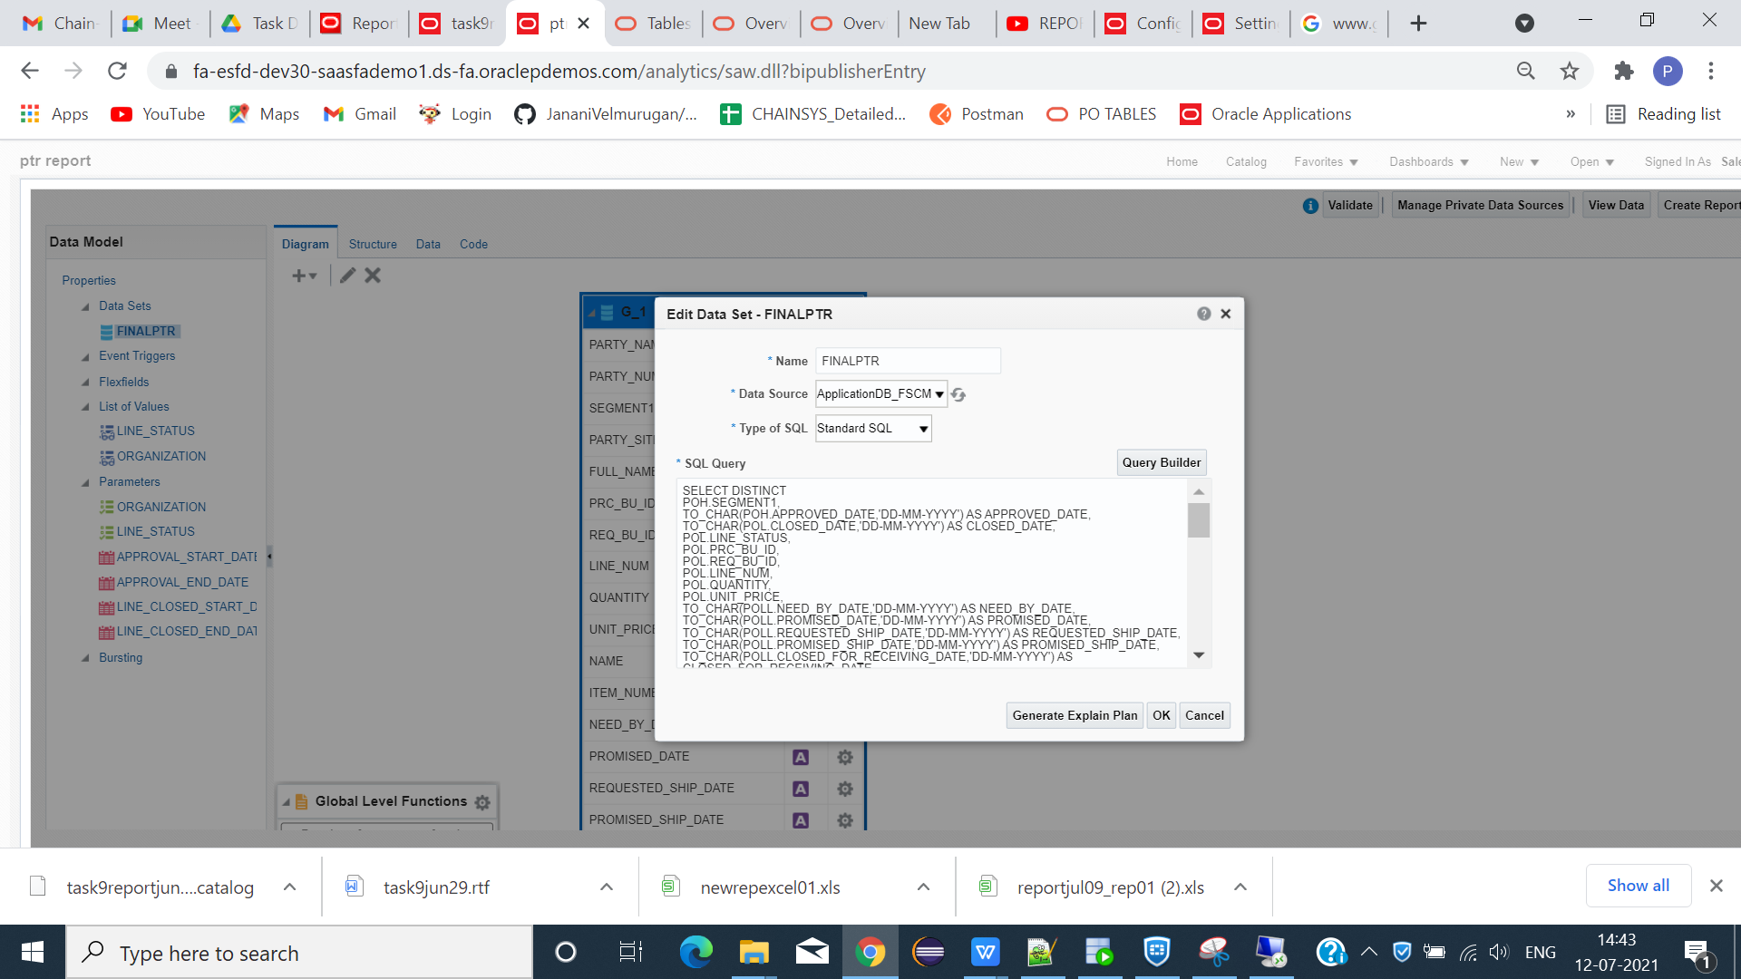

CREATE DATA MODEL WITH SPECIFIED COLUMN NAME MENTIONED IN THE FSD.

**DATA MODEL QUERY**

SELECT DISTINCT

POH.SEGMENT1,

TO_CHAR(POH.APPROVED_DATE,'DD-MM-YYYY') AS APPROVED_DATE,

TO_CHAR(POL.CLOSED_DATE,'DD-MM-YYYY') AS CLOSED_DATE,

POL.LINE_STATUS,

POL.PRC_BU_ID,

POL.REQ_BU_ID,

POL.LINE_NUM,

POL.QUANTITY,

POL.UNIT_PRICE,

TO_CHAR(POLL.NEED_BY_DATE,'DD-MM-YYYY') AS NEED_BY_DATE,

TO_CHAR(POLL.PROMISED_DATE,'DD-MM-YYYY') AS PROMISED_DATE,

TO_CHAR(POLL.REQUESTED_SHIP_DATE,'DD-MM-YYYY') AS REQUESTED_SHIP_DATE,

TO_CHAR(POLL.PROMISED_SHIP_DATE,'DD-MM-YYYY') AS PROMISED_SHIP_DATE,

TO_CHAR(POLL.CLOSED_FOR_RECEIVING_DATE,'DD-MM-YYYY') AS CLOSED_FOR_RECEIVING_DATE,

POLL.QUANTITY_RECEIVED,

POLL.QUANTITY_ACCEPTED,

POLL.QUANTITY_REJECTED,

EGPSIB.ITEM_NUMBER,

POD.QUANTITY_CANCELLED,

POD.DESTINATION_SUBINVENTORY,

POD.QUANTITY_BILLED,

POD.AMOUNT_BILLED,

RSH.RECEIPT_NUM,

PPNF.FULL_NAME,

HZP.PARTY_NAME,

HZP.PARTY_NUMBER,

HZPS.PARTY_SITE_NAME,

HRO.NAME

FROM

PO_HEADERS_ALL POH,

PO_LINES_ALL POL,

PO_LINE_LOCATIONS_ALL POLL,

EGP_SYSTEM_ITEMS_B EGPSIB,

PO_DISTRIBUTIONS_ALL POD,

RCV_SHIPMENT_HEADERS RSH,

PER_PERSON_NAMES_F PPNF,

HZ_PARTIES HZP,

HZ_PARTY_SITES HZPS,

HR_ALL_ORGANIZATION_UNITS HRO,

POZ_SUPPLIERS POS

WHERE

POH.PO_HEADER_ID = POL.PO_HEADER_ID(+)

AND POL.PO_LINE_ID = POLL.PO_LINE_ID

AND POL.ITEM_ID = EGPSIB.INVENTORY_ITEM_ID(+)

AND POL.PO_LINE_ID = POD.PO_LINE_ID(+)

AND POH.VENDOR_ID = RSH.VENDOR_ID(+)

AND POH.AGENT_ID = PPNF.PERSON_ID

AND POH.VENDOR_ID = POS.VENDOR_ID

AND POS.PARTY_ID = HZP.PARTY_ID

AND HZP.PARTY_ID = HZPS.PARTY_ID(+)

AND POH.PRC_BU_ID = HRO.ORGANIZATION_ID

AND HRO.NAME = NVL(:ORGANIZATION,HRO.NAME)

AND POL.LINE_STATUS = NVL(:LINE_STATUS,POL.LINE_STATUS)

AND POH.APPROVED_DATE >= NVL(:APPROVAL_START_DATE,POH.APPROVED_DATE)

AND POH.APPROVED_DATE <= NVL(:APPROVAL_END_DATE,POH.APPROVED_DATE)

AND POL.CLOSED_DATE >= NVL(:LINE_CLOSED_START_DATE,POL.CLOSED_DATE)

AND POL.CLOSED_DATE <= NVL(:LINE_CLOSED_END_DATE,POL.CLOSED_DATE)

AND HRO.NAME IN('Supremo US Business Unit', 'France Business Unit', 'UK Business Unit','US1 Business Unit')

AND POL.LINE_STATUS IN ('CLOSED','OPEN')

AND ROWNUM<100

**LIST OF VALUE QUERY**

**LINE CLOSED:**

SELECT DISTINCT LINE_STATUS FROM PO_LINES_ALL POL

WHERE POL.LINE_STATUS IN ('OPEN','CLOSED')

**ORGANIZATION:**

SELECT DISTINCT NAME FROM HR_ALL_ORGANIZATION_UNITS HRO

WHERE HRO.NAME IN('Supremo US Business Unit', 'France Business Unit', 'UK Business Unit','US1 Business Unit')

* IN PARAMETER MAP CORRESPONDING LOV AND ENABLE REFRESH ON OTHER PARAMTER.
* SAVE DATAMODEL -> DATA -> VIEW -> SAVE AS SAMPLE DATA -> EXPORT.

**BI PUBLISHER(WORD)**

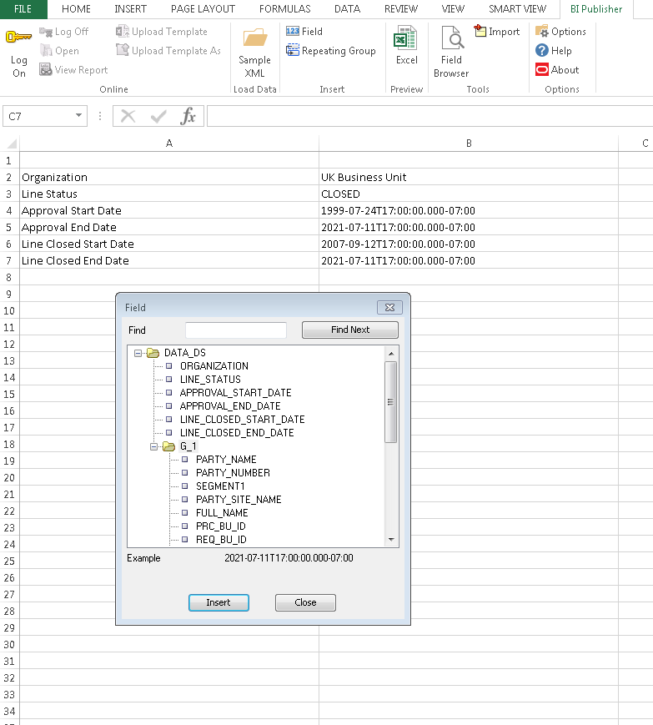

LOAD SAMPLE DATA -> FIELDS(PARAMETER IN SHEET ONE).

SAVE FILE AS -> EXCEL 97 ->2003 WORKBOOK.

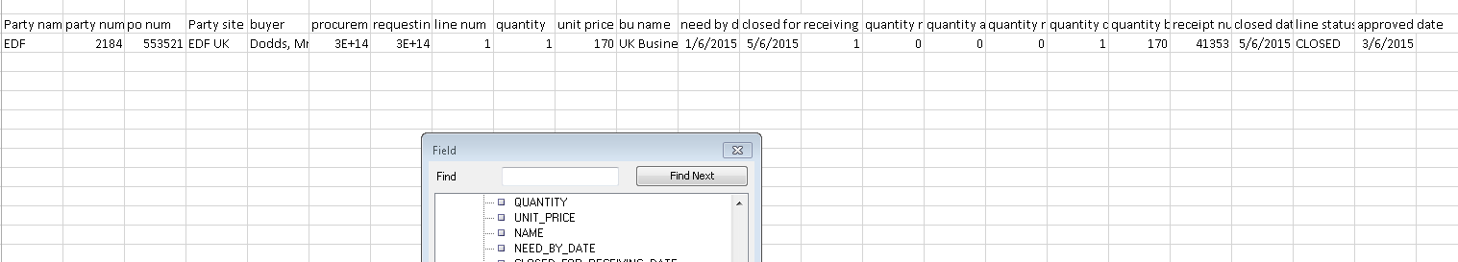

IN SHEET 2 REPORT COLUMNS.GIVE REPEATING GROUP.

CLICK SAVE -> EXCEL(TO PREVIEW OUTPUT).

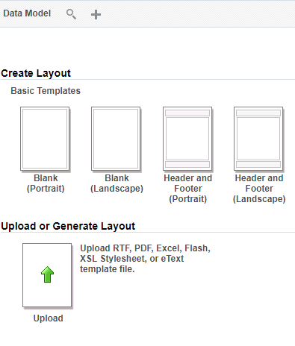

LOAD -> DATA MODEL -> UPLOAD LAYOUT -> SAVE REPORT -> REPORT GENERATED IN EXCEL FORMAT.

======================================================